January Newsletter

  - January 1, 2017

Ringing in the new year |  | In This Issue

I would like to start off by saying thank you to all the parents that helped and participated in our holiday festivities. It was great to see people at the Polar Express themed Winter Wonderland. We had so many families bring in an item for the pot luck, it was a huge success. I was busy in the hot chocolate room, but I did see pictures of the children enjoying the games, making cookies, eating, visiting Santa, and dancing the night away under the bubbles! I know that I had a great time and hope that you all did as well, I thought that it was a great night. Papa Joe the storyteller entertained us with holiday stories, and then each room enjoyed their class parties. I am sure I speak for everyone when I say thank you for all the great treats they enjoyed at each party.
With all your help last month we were able to donate a couple hundred pounds of food to the food bank, warm clothes to New Horizons, and helped sponsor a family to ensure that they all enjoyed the holidays. The results of the penny wars are posted on the wall in the entry way.
It truly has been a season of giving. Thank you all for all you have done!
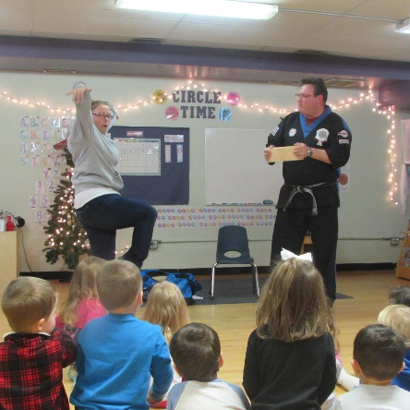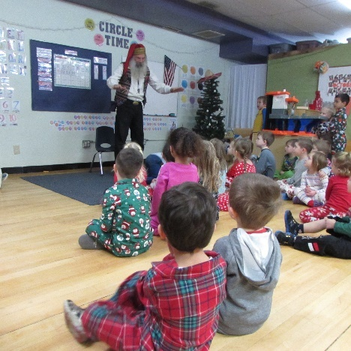

Welcome 2018!
by Ms. Dani
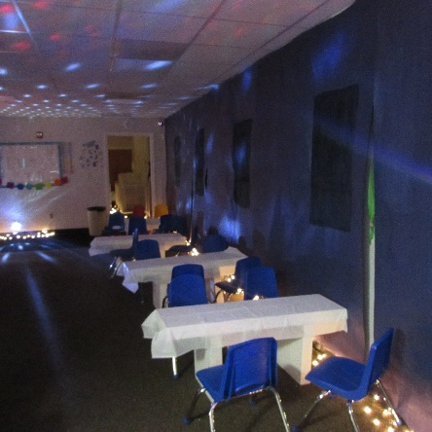
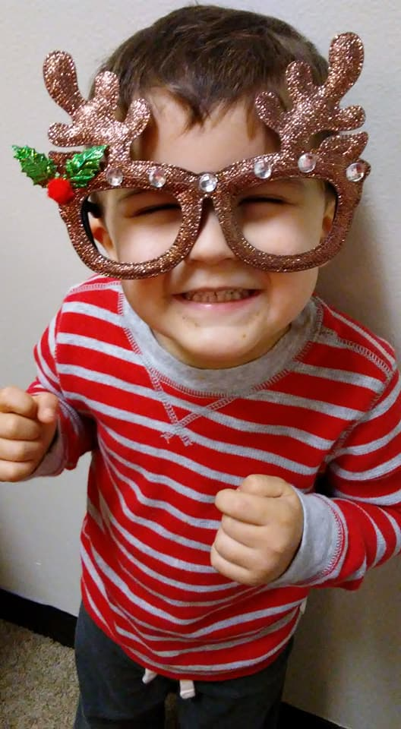

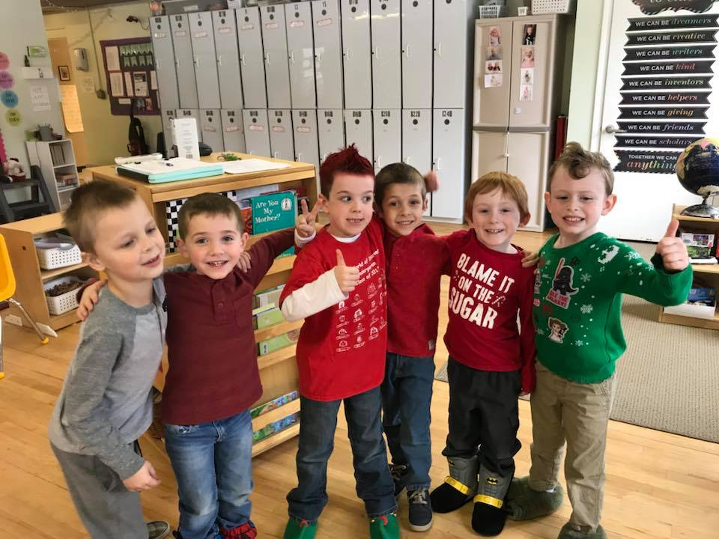

Spirit Week!
Everyone was very festive for spirit week. We had many of our families participate and you could feel the spirit of the holidays through the children’s excitement.
We are all very much looking forward to the New Year and resetting all the schedules and getting back to our normal routines.

2018
As we begin the new year I would like to remind everyone, that if any of your personal or child’s emergency information has changed to please see the office or your child’s teacher to update that information. I cannot stress how important it is to have the most current and up to date information on file. This also goes for any medicine that your child may have at school. This is a great time to check on the status of any medicine, extra clothes, or outdoor gear that may have just been sitting around for a while.

Contract Hours
I would like to remind everyone that upon enrollment every family filled out a contract for services. In doing so, you also agreed to certain drop off and pick up times. I then staffed the center based upon those times. When families veer from those stated times it can cause staff to child ratio complications. It is of the utmost importance to maintain proper ratios and stay within the state compliance guidelines at all times.
I understand that situations may arise and on occasion a family may need to alter those times, in that circumstance please call the center and get prior approval so that we can make sure we are staffed appropriately.
The handbook also states that our center closes at 5:30pm. If you arrive after 5;30pm you are responsible for the late fee. The late fee is $1.00 per minute. That amount is due to the teacher that stays with your child. If this is not paid, the handbook does state that this amount will be added to your tuition. If you are in need of a new parent handbook to refresh the rules and policies of The World of Discovery please see the office.

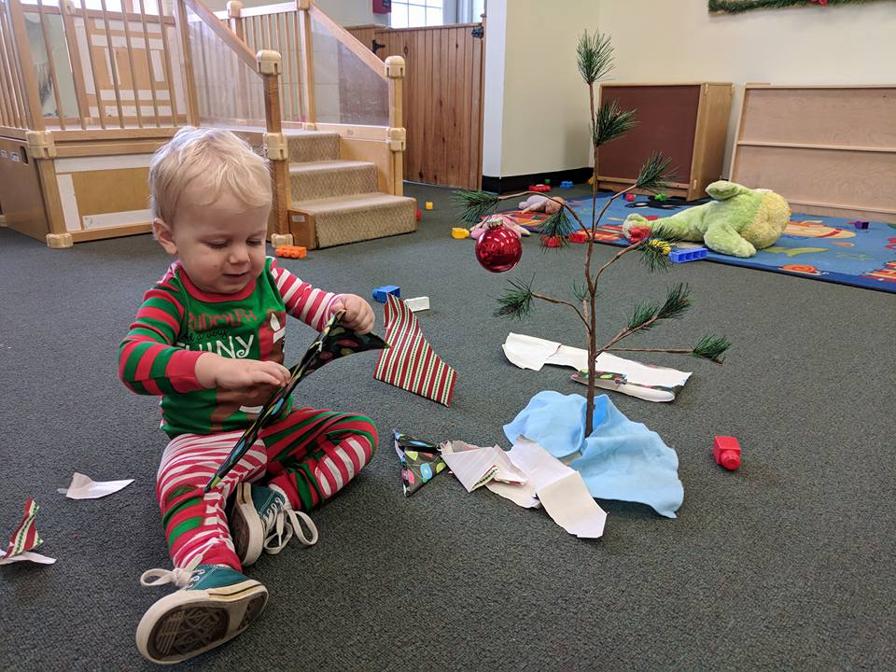

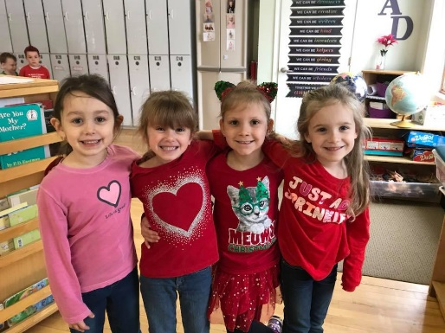

Outside Gear
Please be sure to continue to bring in outside gear. Please label everything that you bring into the center, it never fails that things get mixed up or brought home by accident, if they are labeled, it will help get them to the correct home!

It is not only outside gear that is going missing. We have noticed that many things are not coming in to the center labeled. New clothes, different outside gear, different nap gear, or stuffed animals are common items that are getting misplaced, or someone else believes them to be theirs.

One of the most difficult to fix is when someone takes home the wrong car seat. I am urging everyone that leaves a car seat in the front hallway to please make sure and label it. We have left masking tape out there as well as a sharpie so that all seats can be labeled.
Again, if you have dropped off and know that you will be picking up and do not need to leave the seat please be sure to take it with you.

If you happen to be cleaning up from the holidays or downsizing to fit in new items we will gladly appreciate any book donations that you may have!
I will also be asking if any families have sleep sacks that their child(ren) have outgrown and are willing to donate we will gladly accept them.
We are still awaiting the final draft of the new NH Childcare Licensing Rules and Regulations. As soon as we know of any changes we will let you know as well.
I hope that everyone has a safe and happy New Year. I am excited to see what 2018 has in store for everyone! I wish nothing but well wishes and good fortune to come to all.

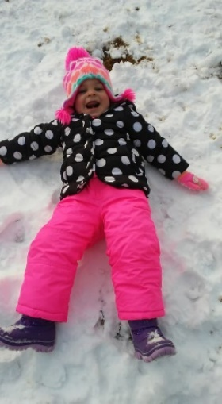

Outside is “snow” much fun! 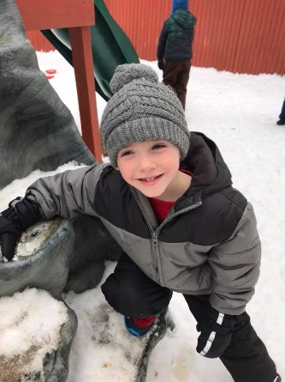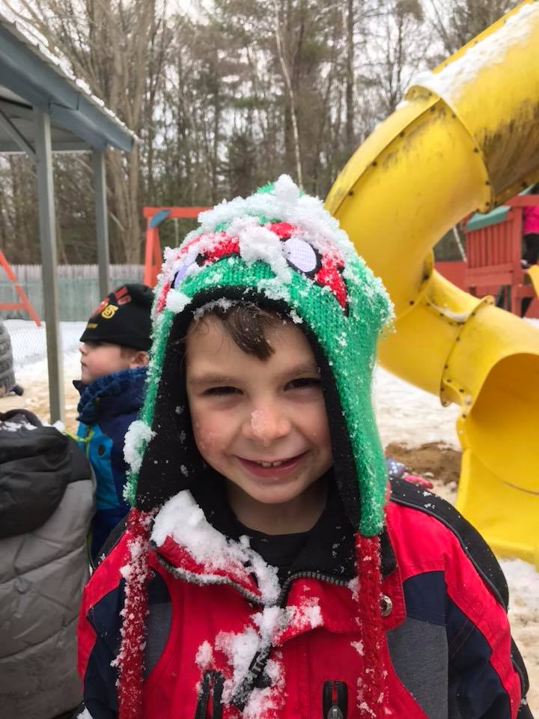

Just a quick note from the office.

